Web Application Project

Appoinment scheduling application

allynn alvarico

2023

Appointment Scheduling Application

Table of Contents

Introduction 3

About me 3

Personal Goal 3

About the Project 4

Appointment Scheduling Application 4

Goal for the Project 4

Components 4

Requirements 4

Development Requirements 5

User Registration and Login 5

*User Registration 5*

*Login Form 7*

Development Stages 8

First Stage of Design 8

# Introduction

## About me

I am Allynn Alvarico, I just finish my Fetac on Software development course and I wanted to do a personal project to put in all the knowledge that I have learned on my studies together. I have chosen a project for healthcare which will be an *Appointment Scheduling Application,* and this will be a web application. The reason why I chose it to be a web application is that I wanted to learn JavaScript cause while I was doing the course, we did not learn any JavaScript and I wanted to use the skill that I have learned in my Database module and connect the web application to a database.

On this project I will set a time limit for myself of 6 months just to see where my skill level at. The start of this project will be on the 1st of June 2023 and will try to complete the project on 30th of November 2023 and the tracker for my progress will be GitHub. Once I have finished the documentation, I will immediately start on the project which give me 5 weeks.

## Personal Goal

Finishing the project within the time limit that I have imposed to myself and be able to practice time management on this project. Learn how to have a clean and maintainable codes, making sure other people or developer can read and modify my codes. Be able to make documentation on the process of making an application.

# About the Project

## Appointment Scheduling Application

Appointment scheduling is the process of booking and managing appointments between service providers and customers. In order to select a time for the appointment that both sides can agree on, it entails coordinating schedules, availability, and preferences of both parties. The procedure normally begins with **gathering information from the client**, such as **name**, **contact information**, and the **service needed**, and then **confirming the service provider's** or **team's availability**. The appointment may be arranged after an appropriate time window has been found, and both parties can get confirmation through email, SMS, or other contact methods. Appointment scheduling that is effective may enhance client satisfaction, boost productivity, and **lessen scheduling mistakes** or **conflicts**. This procedure may be automated with the use of an appointment scheduling program, which makes it simpler for service providers and clients to schedule appointments and save time.

## Goal for the Project

My goal for this project that I have provided above is I will develop an efficient and user-friendly appointment scheduling application that streamlines the scheduling process for both service providers and customers. Automating the appointment scheduling process, my aim is to **increase client satisfaction**, **improve productivity** and **reduce scheduling conflicts.** The main goal of this project is to simplifies the appointment scheduling process and saves time for both the service provider and the client.

## Components

I will be using will be **HTML**, **CSS**, and **JavaScript**. For Database will be using the **MS Access** and **Java** language.

* User interface design
* Backend development (need to learn this)
* Frontend development
* Security (will look up)
* Testing
* Deployment

## Requirements

**Application requirements are:**

|  |  |  |
| --- | --- | --- |
| * User Registration and Login | * Appointment Scheduling | * Appointment Management |
| * Provider Management | * Search and Filter | * Payment integration |
| * Communication | * Security and Privacy | * Mobile-Friendly |
| * Scalability |  |  |

# Development Requirements

## User Registration and Login

### User Registration

User Registration is a process that user creates an account on the application and then saves the personal information provided by the user. This information is stored in a database which allows the user to log in and access the application in the future. This is an important process because this enables the application to identify and personalise the user’s experience.

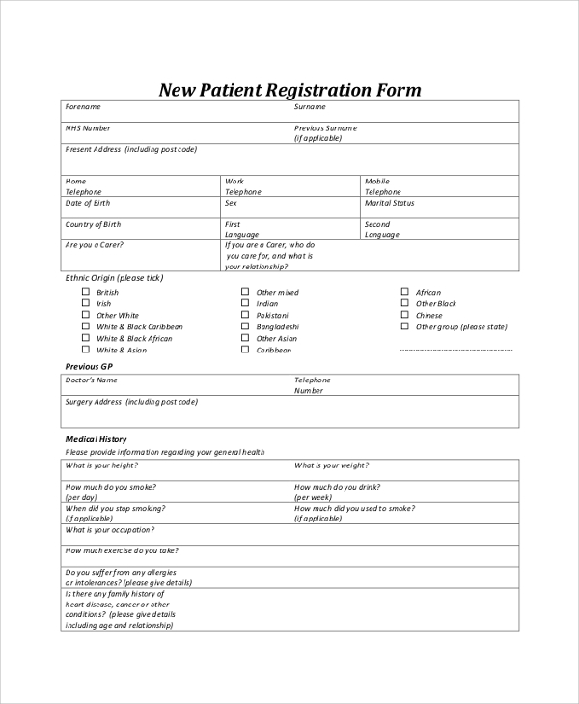

**Needed for this Form are:**

* **Name**
  + - Input type “text”
* **Surname**
  + - Input type “text”
* **Mailing Address**
  + House number or Block number
  + Street Address
  + City/Town
  + State
  + Postal Code
* **Phone Number**
* **Mobile Phone**
* **Email Address**
  + - Input type “Email”
  + **Confirm Email Address**
    - Input type “Email”
* **Next of Kin**
  + Name
  + Surname
  + Relationship
  + Contact number
* **Password**
  + - Input type “Password”
  + **Confirm Password**
    - Input type “Password”
* **Date of Birth**
  + - Input type “date”
  + Calendar function
    - Day
    - Month
    - Year
  + Display age (optional)
* **Gender**
  + Input type “radio button
* **Medical History –** next page or comment (optional)
* **Submit Button**
* **Reset Button**

### Login Form

Once the user has successfully registered for an account, they can login to the application using the Login Form. The login form requires the user to enter their login information and password. Once they submitted their login information, the application will check the credentials of the stored data on the database and grants or denies access to the user.

* Username and password
* Email address and password
* Full name and assigned user number and password.
* Registered application number and password

Successfully having login to the application this will show a page to retrieve the patients’ medical information, medical cards, GP visit cards, Local health centres located, Prescribed drugs, prescription letters (can be access by local pharmacies), Other services, Tax reliefs and other support.

Resources 🡪 Citizen information

<https://www.citizensinformation.ie/en/health/health_overview.html>

when a GP checks the patient’s medical chart this will show on the GPs screen

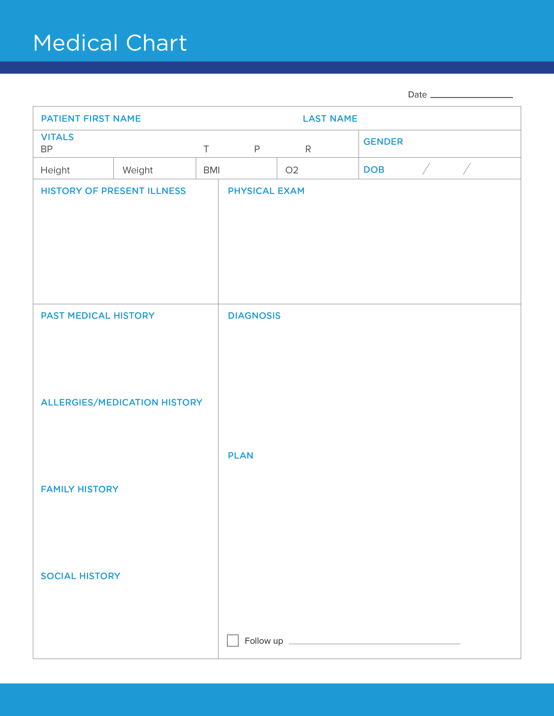

# Development Stages

## First Stage of Design

* Make an initial design to the web application.
  + Good and clean design.
    - Design a navigation and layout.
    - Draft for the UI and UX
    - Accessibility
      * Consider the users with disabilities.
        + Text-to-speech functionality
        + Keyboard navigation
    - Soft color will be used.

## Example Layouts

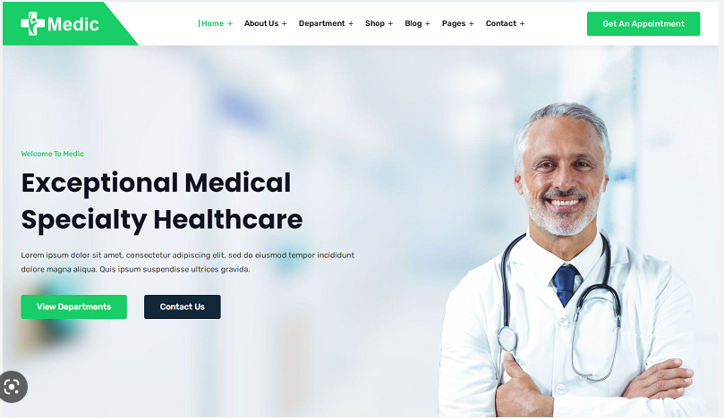

## Color Templates

Colorhunt - <https://colorhunt.co/palettes/pastel>

To consider:

#EDF2F7, #E4E8F4, #8FA2CA, #B5C6B8, #48523D

## Second Stage of Design

### Planning Pages

1. Index
   1. Blog
2. Error Page not Found.
3. Registration Form
4. Login Form
   1. Social Login
5. Appointment Booking
   1. Appointment Calendar
   2. Waiting List
6. Service Providers
   1. Service Provider Dashboard
   2. Analytics and Reports
   3. Services
7. Payment Processing Page
8. Confirmation Page
9. Clients' Dashboard
   1. Account Settings
10. User Feedback
    1. Help & Support
    2. Reviews and Ratings
11. About Us
    1. Contact Us
    2. Privacy Policy
    3. Terms and Conditions
    4. Cancellation Policy
    5. FAQ
12. Referral Program
13. Social Media links

In the planning stage of the web application development, I have identified a set of pages that must be created. These pages serve as the foundation of my appointment scheduling application and will provide essential functionality to the users. To ensure consistency and efficiency in design, I will employ the use of common templates across these pages.

To ensure consistency and a unified user experience, utilising common templates across these pages. Common templates will provide a consistent layout, design elements, and navigation structure, ensuring that users feel familiar and comfortable when moving across different sections of the application.

By employing common templates, I can streamline the development process, as updates or changes to the template will automatically propagate to all pages using it. This approach also enhances the overall aesthetics and usability of our application, as users will find it easy to navigate and interact with the familiar design elements present throughout the various pages.

Through the use of these common templates, I aim to create a visually cohesive and user-friendly experience for the users, promoting ease of use and effective interaction with the appointment scheduling application.

## Third Stage of Design

### Mock up Design.